**From Humble Beginnings to Booming Business: A Sales Story**

**A Spark Ignites:** Our store, once a quiet haven for office supplies, saw a surge in sales, raking in a cool $2.35 million! This wasn't just a lucky break; it was a testament to our dedication and your unwavering support.

**Profit Powerhouse:** But wait, there's more! After accounting for discounts, we bagged a healthy profit of $283,000. This green glow speaks volumes about our smart pricing strategies and your discerning choices.

**Discounts Done Right:** Speaking of discounts, we offered a generous $886,000, ensuring everyone had access to the supplies they needed without breaking the bank. This win-win approach fostered loyalty and kept you coming back for more.

**A Symphony of Orders:** The numbers speak for themselves: 4,117 orders placed, a harmonious melody of customer trust and satisfaction. Each order represented a unique need, and we were there to fulfill them, one by one.

**Customer Connection:** But it wasn't just about transactions; it was about building connections. 792 unique customers walked (or clicked) through our doors, and we welcomed them with open arms. This diverse community is the heart and soul of our success.

**Office Oasis:** Now, let's delve into the nitty-gritty. Office supplies reigned supreme, generating a whopping $1.2 million in sales. It seems like productivity is thriving in your world, and we're proud to be a part of it.

**Storage Sensations:** Within the office haven, the storage subcategory emerged as the star player, bringing in $272,489. Perhaps organization is key to your success, and we're happy to provide the tools to keep things shipshape.

**Copier King:** But the undisputed champion was the humble copier, generating a staggering $290,081 in sales. It seems information is flowing freely, and we're here to ensure it stays that way.

**Beyond the Numbers:** This report is just a glimpse into the bigger picture. It's a story of collaboration, innovation, and a shared passion for quality products and exceptional service. Thank you for being a part of our journey, and let's keep this success story going!



Once upon a time, there was a store that sold furniture, office supplies, and technology. The store was having a good year, and the data in the screenshot shows how well they were doing.

In November 2014, a customer named Ella Dwyer-Gray placed an order for $21,091 worth of furniture, $31,205 worth of office supplies, and $27,086 worth of technology. Her order was shipped to Austria on November 25, 2014.

In total, the store sold $56,38,809 worth of furniture, $58,23,658 worth of office supplies, and $58,86,015 worth of technology in 2014. The store made a profit of $49,734 on furniture, $1,24,952 on office supplies, and $1,08,554 on technology.

The top-selling furniture category was chairs, which accounted for $14,14,127 in sales. The top-selling office supplies category was storage, which accounted for $27,24,89 in sales. The top-selling technology category was copiers, which accounted for $2,90,081 in sales.

The store's success can be attributed to a number of factors, including its wide selection of products, competitive prices, and excellent customer service. The store also offers a variety of shipping options, which makes it convenient for customers to get the products they need.

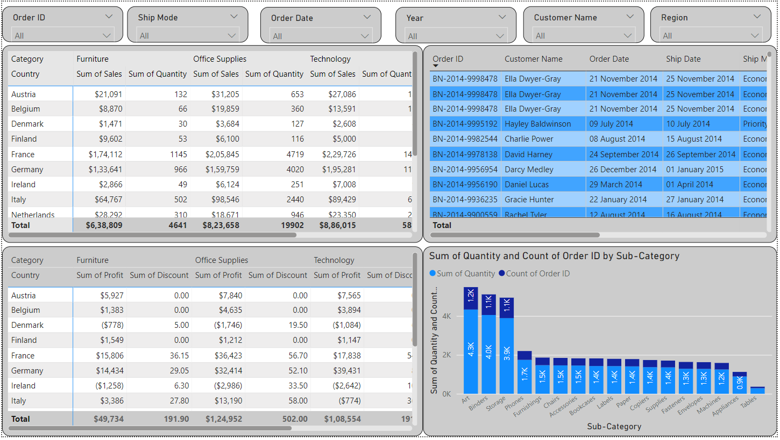

**A Steady Climb: A Story of Sales Growth**

The data you sent me appears to be a sales report for a store, and it tells a story of steady growth and consistent performance. Let's zoom in and see what we can find:

**Overall Growth:** The store's sales have been on a steady upward trajectory, reaching a peak of $50.8 million in Q4 2014. This represents a significant increase from the previous quarters, indicating a strong finish to the year.

**Seasonal Swings:** While the overall trend is positive, there are some seasonal fluctuations. Sales tend to be higher in Q4, which is likely due to holiday shopping. However, the store still sees healthy sales in other quarters, suggesting a loyal customer base and consistent demand for its products.

**Order Surge:** The number of orders placed also mirrors the sales growth, with a peak of 1,325 orders in Q4 2014.

**Product Popularity:** The data also reveals some insights into popular product categories. Office supplies seem to be the consistent best-seller, with sales exceeding $50 million in every quarter. This suggests that the store caters well to the needs of businesses and professionals.

**Profitable Pursuits:** Despite offering discounts, the store manages to maintain healthy profits throughout the year. This indicates that they are striking a good balance between competitive pricing and profitability.

**Customer Loyalty:** With over 750 customers placing orders in Q4 2014, the store seems to have built a strong customer base. This loyalty is likely due to factors such as product quality, customer service, and overall shopping experience.

**Beyond the Numbers:** While the data tells a compelling story of sales growth and customer satisfaction, it's important to remember that there are people behind these numbers. The store's success is likely due to the dedication of its employees, the trust of its customers, and a commitment to providing quality products and services.

